**PROJECT TOPIC: Cotton Disease Prediction**

**Group No.: G - 95**

**Project Group Members:**

1. Vineet Kumar (A- 75 / 201599031)
2. Pawan Singh (A – 68 / 201599017)
3. Shreya Gupta (C – 51 / 191500783)

**Project Supervisor:** Dr. Ankush Agarwal, Assistant Professor

**About the Project:**

Cotton is also called “White Gold” and “The King of Fibers.” For growers, processors, exporters, and producing countries, cotton is the earnest point of supply. This work presents cotton plant disease detection using image processing techniques for an automated vision system used in agricultural fields. In agriculture research, automatic plant disease detection is essential in monitoring large fields of crops and thus automatically detects symptoms of the disease as soon as they appear on plant leaves. It is very difficult for a farmer to identify various diseases in plants.

**Motivation:**

This area of research appears to have great potential in terms of increased accuracy. It will be implemented along with several visualization techniques to detect and classify the symptoms of plant diseases

Detection of plant diseases in the early stage would facilitate farmers to boost the crop yield, which successfully improves the country’s gross domestic product.

Future analysis can embrace an evaluation of the capability of the algorithm rule to diagnose the cause of the lesion (what pest or disease) It is going to be enforced with the utilization of software which can be utilized throughout actual field visits to facilitate the creation of maps of the extent of infestation by pests and diseases

**Project Planning:**

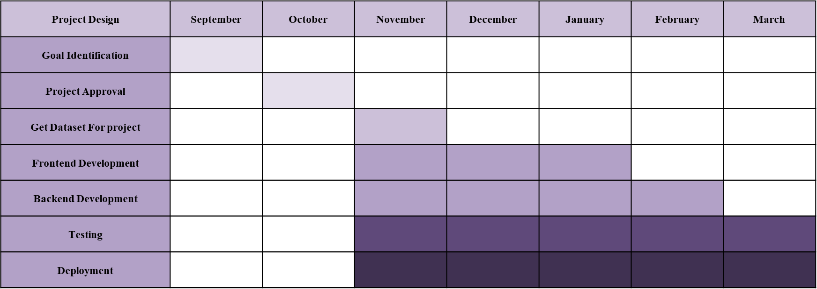

**Tools required:**

1. **Hardware Requirements:**
   * + 1. Processor: Vostro
       2. RAM: Up to 8 GB
       3. Hardware devices: Mobile, Laptop
       4. Hardisk: 8 GB
       5. Display: 6-inch,14 inch
2. **Software Requirements:**
   * + 1. Deep Learning – Renset 50, Python, TensorFlow
       2. User Interface Design: HTML, CSS & BOOTSTRAP
       3. Web Browser: Google Chrome
       4. Google Collab

**Signature of Project Supervisor: _____________________**